FMX Mobile Application Development
Lab Exercise 02.05 : Running an InterBase Script
You can execute sql scripts in the Interactive SQL window of the IBConsole. To create, open or modify data definition files, you can use a text editor such as Notepad++.

CONNECT Statement
Every SQL script must begin with a CONNECT statement. The CONNECT statement specifies a complete path to the database, a user name, and a password. However, if you connect to a database beforehand, you may omit the CONNECT statement when executing an SQL script in the Interactive SQL window.
If you do specify a connect statement, make sure to modify the values accordingly. The SQL scripts that accompany this tutorial begin with the following CONNECT statement:
CONNECT 'C:\Data\EMBEDDEDIBLITE.IB'
USER 'SYSDBA' PASSWORD 'masterkey'
NOTE: Before executing a script with the above CONNECT statement, check your paths and connection statement
Run the EmbeddedIBLite.SQL Script
- Download the EmbeddedIBLite file to your computer.
- Load the EmbeddedIBLite.SQL script.
- Execute the query.
- To confirm that the tables now exist, click on Tables item in the left pane of IBConsole.
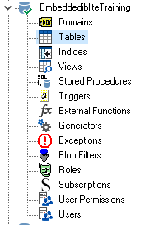
You should see the following tables:
